**CHEONG Soo Pieng (1917-1983)**

Cheong Soo Pieng was a Chinese born artist who became well known for his contributions to Singapore modern art. In Nanyang, Soo Pieng’s Chinese art training was integrated with the lush tropical landscape and the arresting allure of local communal practices. Soo Pieng was part of a group of artists who visited Bali, Indonesia in 1952 in search of the Nanyang Style (Southeast Asian themes visualised with Western art techniques). The resulting imagery in the works created by the artists was exhibited back in Singapore the following year in the hugely lauded exhibition, *Four Artists to Bali*. This provided the stimulus for these artists to further develop this particular genre of art. For Soo Pieng, his artistic excursions were not confined to Singapore. He also travelled to Sarawak, Borneo in 1959 and resided in Europe from 1961 to 1963, where he held solo and groups shows and where he also dabbled with abstraction in his works. Yet, Soo Pieng is recognised for his development of distinctive figural types known as elongated figures, female bodies with elongated limbs. The figural types he developed in the 1950s were reassessed and reworked in the 1970s. These later works reflected matured handling and refinement, reinforcing his personal stylisation of the subject matter.

Cheong trained at the Xiamen Academy of Fine Arts and Xinhua Academy of Fine Arts, Shanghai in Chinese and Western art. The confluence of Eastern and Western methodologies and imbuement of new ideologies proved to be an impetus to his later artistic development.

Cheong arrived in Singapore after World War Two, impelled by the Sino-Japanese war and the subsequent civil unrest in China. At the invitation of his teacher in Xiamen and the first principal of the Nanyang Academy of Fine Arts (NAFA), Singapore, Lim Hak Tai, Soo Pieng began teaching at NAFA where he became highly influential during his tenure from 1947 to 1961. Many established artists in Singapore and Malaysia today were taught and inspired by the dynamism and creative vision of Cheong. He devoted his time to be a full time artist after years of teaching,.

As an artist, Cheong was not confined to the possibilities of painting, producing numerous works of sculpture and metal relief throughout different stages of his career. His works were much sought after by local and foreign collectors. They included Michael Sullivan (art historian and collector of Chinese art), Loke Wan Tho (cinema magnate) and Frank Sullivan (press secretary of the 1st Prime Minister of Malaysia and art collector). Notably, Soo Pieng received the Meritorious Public Service Medal in 1962.

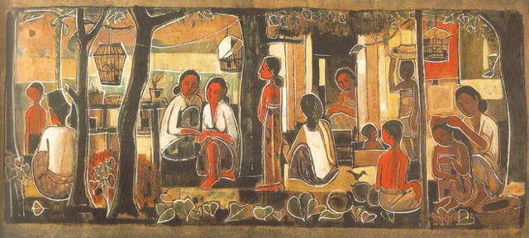

Cheong Soo Pieng, *Tropical Life*, 1959, Chinese ink and gouche on rice paper, 43.6 x 92 cm, National Visual Art Gallery, Malaysia.

**References and Further Reading**

---- (2013) *SOO PIENG*. Singapore: Nanyang Academy of Fine Arts.

Piyadasa R. and Sabapathy, T. K. (1979) *Pameran retrospektif pelukis-peukis Nanyang*. Kuala Lumpur: Muzium Seni Negara.

Yeo, Wei Wei. ed (2010) *Cheong Soo Pieng: Bridging Worlds*. Singapore: The National Art Gallery, Singapore.